Intro to Game Programming

CS38101, Fall 2023

Joshua Thompson - 811159872

Initial Project Report

Dimension Shift

# Description

This will be a 2D platformer where jumping causes a complete change in the environment. The player must touch the white platform in each level in order to progress. Coins scattered throughout the level increase the score. If the player makes it to the end of the levels without losing all their lives, they win. Otherwise, they must restart.

# Core Mechanics

## Game Loop

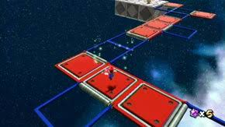 The main mechanic of the game revolves around jumping. Whenever a player jumps, everything around them changes: their environment, their music, their platforms, etc. The only things that stay constant are the sounds of the player jumping, the player, and the safe platforms. The concept is like the Super Mario Galaxy red and blue panels, where if a player jumps and spins, the panels shift.

There will be two dimensions that will mark what state everything is in: Summer and Fall. The platforms can change their state based on what dimension they are in. Some examples are changing their position, direction, orientation, shape, and size.

## Levels

There will be three types of levels: Tutorial, Normal, and Challenge. These levels separate the difficulty of the levels. Tutorial levels will let the player learn a new type of platform. Normal levels will be the most common type of level, allowing the user to get used to the platform. Challenge levels will be the most difficult, testing a user’s skill. The initial goal is to make thirty levels: three levels per platform type, nine challenge levels to merge the platform types, and one final level to merge all platform types, totaling twenty-five levels.

## Score

The player can increase their score by collecting coins placed throughout the levels. Collecting coins will increase their score by one hundred per coin.

## Obstacles

Other than the state of platforms, the other obstacle will be a timer. Once a timer reaches zero, the player will lose the level, and will have to restart. The timer will reflect the difficulty of the level.

## Restarting

If a player runs out of lives, they will be put back to the tutorial level that they last completed. They will lose fifty points per stage that they completed upon reset. The stage counter will reset, so if a player dies right after a reset, they will only lose fifty points and go back to the same tutorial level.

# Visual Aesthetics

## Environment

The game will take place in a 2D environment. The visual theme of the game will be centered around the time between summer and fall. The two dimensions will be themed around their named season. Whenever the dimension changes, a white streak will pass quickly along the screen, each color changing to their alternative form one the streak has passed.

## Platforms

The platforms in each dimension will have distinct colors that mark their current state. For example, a green platform will appear in Summer, and its other state will appear in Fall as red.

## Coins

Coins will have their own animations. Their default state is a medium speed spin. Whenever a coin is collected, it will flicker white for a few seconds before disappearing. The given points will be shown above the coin during the flicker.

# User Interface

## Title Screen

On the title screen, the following options will display: Play, Settings, Exit. If the user selects the play button, two more options will appear: Story, Free Play. If they select Story, they will be taken through each level one by one. If they select Free Play, they will see all levels displayed in a grid format. They can then pick a level to play from there. Once they complete the level, they will be returned to the level selection screen.

If the user selects the settings button, they will be taken to a screen where they can adjust the volume of sounds and/or music, turn off the sounds and/or music, and change their control scheme. From the settings menu, if they choose to change their control scheme, two buttons will appear with the WASD and Arrow key schemes. If they select the exit button from the title screen, the window will close.

## In Game

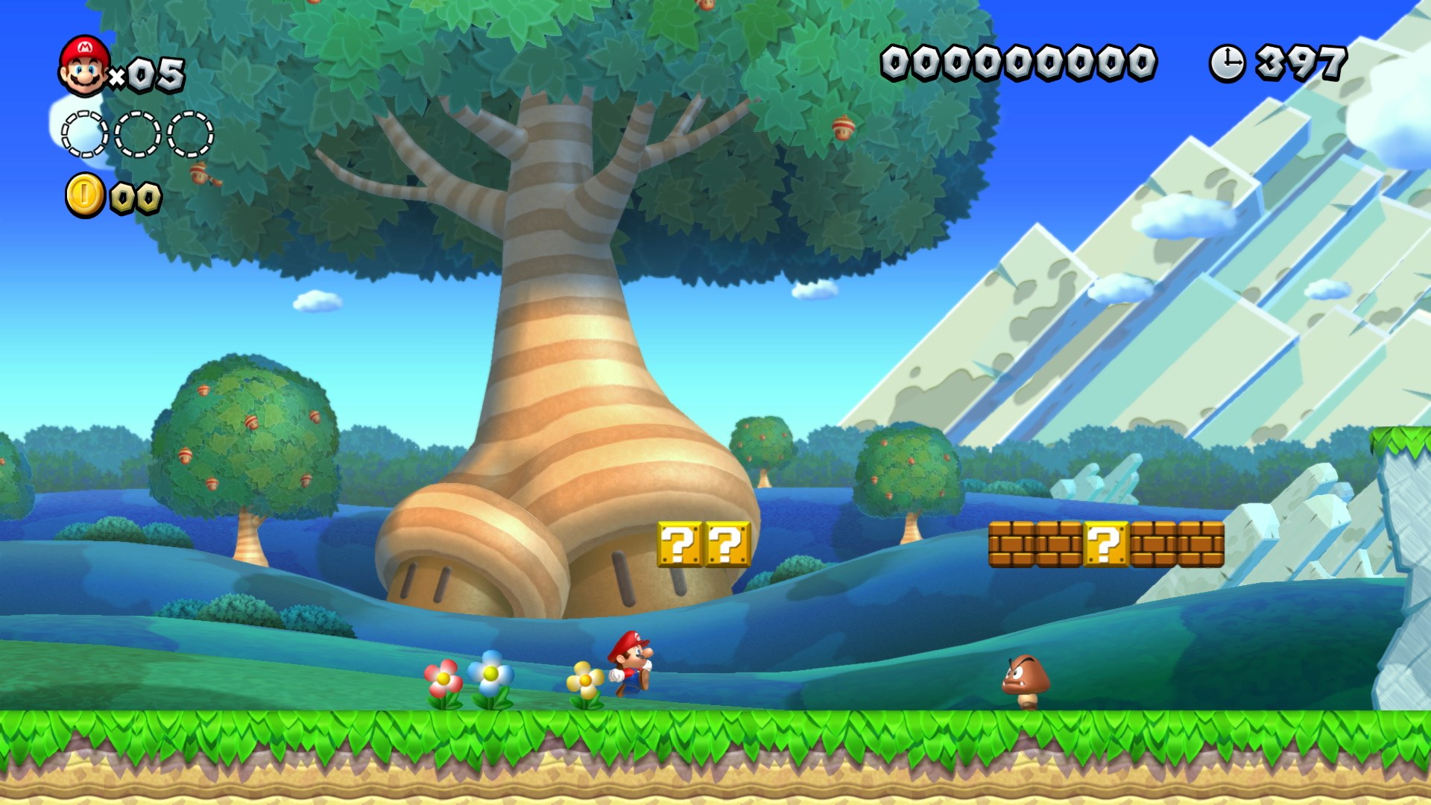When the user is in a level, the top left corner of the screen will display information such as the user’s lives, their score, and the timer will be displayed. In the top right will be a gear symbol in a box, marking the settings. This setting screen will be the same as if they chose it at the title screen with one exception. If the user does not want to go to the menu to exit, they can press the exit button that appears in this menu. It will be like a classic Super Mario level:

# Music / Atmosphere

## Title Screen

The title screen will incorporate themes from both Summer and Fall. The music will be blended as well, along with solos from each season.

## In Game

The current dimension will determine the theme of the game. When the dimension is Summer, it will incorporate summer themes, such as a blue sky with a bright sun and beach themed music. When the dimension is Fall, it will incorporate fall themes, such as a cloudy sky with leaves falling and calm music. The change in themes will be marked by a soft, mystical sound effect.

# Controls

The user will have access to two control schemes. The first control scheme is “WASD”. This will enable the W, A, S, and D keys to be pressed. The second control scheme is “Arrow keys”. This will enable the Left, Right, Up, and Down arrow keys to be pressed. Both schemes share the spacebar. The following list the controls for each key:

* W, Up Arrow: Up
* A, Left Arrow: Left
* S, Down Arrow: Down
* D, Right Arrow; Right
* Spacebar: Jump

# Target Audience

The intended audience for this game is everyone ten and up (E 10+). It is meant to be a family game like the Super Mario series.